­­­­­­Project PLAN DOCUMENTATION

INTERNET BANKING  
SYSTEM

**Author:** **Ahmed Hamdy**

Creation Date: 2/5/2019

Version: 2.0

|  |  |  |  |  |  |  |  |
| --- | --- | --- | --- | --- | --- | --- | --- |
| Version | Implemented By | Reviewed by | Review date | Approved  By | Approval  Date | Comments  By Author | Comments By Reviewer |
| 1.0 | Ahmed Hamdy |  |  |  |  | Initiate the project plan |  |
| 2.0 | Ahmed Hamdy | Alaa Gamal | 3-May-19 |  |  | Adding work breakdown structure, verification and validation plan and communication plan | 1. Duplicated information about customer requirement , you can just refer to the customer requirement document 2. Project Approach is V model not agile |

**Table of Contents**

1. Introduction 2

1.1 Purpose of the plan 2

2. Project Overview 3

2.1 Objective of the project 2

2.2 In Scope and Out of Scope 3

2.3 Assumptions and Constraints 3

2.4 Milestones and deliverables 4

2.5 Schedule and Budget Summary 5

2.6 Project Goals 5

3. Project Organization 5

3.1 Project Approach 5

3.2 Communication Plan 6

4. Managerial Process Plans 7

4.1 Start-up plan 7

4.1.1 Roles and Responsibilities 7

4.1.2 Project Staff Training 8

4.2 Work Plan 8

4.2.1 Work Breakdown Structure 9

5. Verification and Validation 10

6. Approval 10

1. Introduction

1.1 Purpose of the plan

The Internet Banking System Project Plan will provide a definition of the project, including the project’s goals and objectives. Additionally, the Plan will serve as an agreement between the following parties: Project Manager, Project Team, and other personnel associated with and/or affected by the project.

**The Project Plan defines the following:**

1. Project Objective
2. Organizational, Team, User and project goals
3. Scope and expectations
4. Roles and responsibilities
5. Assumptions and constraints
6. Project management approach
7. Project budget

2. Project Overview

2.1 Objective of the project

This Web Portal will serve as an interface for all the banking services where the client can easily access his/her account/s, perform inter account transactions and to inquire about the previous transactions.

2.2 In Scope and Out of Scope

* **Scope of the project**

With Internet banking System, consumers aren't required to visit a bank branch to complete most of their basic banking transactions. They can do all of this at their own convenience, wherever they want—at home, at work, or while on the go.

Internet banking System requires a computer, an internet connection. In order to access the service, clients need to register for their bank's online banking service. In order to register, they need to create a password. Once that's done, they can use the service to do following features:

* The client can register a new account.
* The client can login to the system using a secure login.
* The client shall have a direct access to his/her different accounts where he can view a history of previous transactions.
* The client should have the ability to perform transactions between different accounts.
* Transaction per second for website is 3 milliseconds.
* The web application works on OS: Windows.
* The web application works on Browsers: Chrome.
* **Out of Scope**

These feature are not in the scope of work as they are not included in the software requirement specifications as per our agreement with the customer:

* Test Automation.
* Web application Security characteristics except: User authentication and Session time out.
* Web application Performance testing except: Load testing.
* The browser does not support any browser other than Chrome.
* The browser does not support any OS other than Windows.

2.3 Assumptions and Constraints

* **Project Constraints**

The following represent known project constraints:

* The development team shall use pure Javaprogramminglanguage in the development of the back-end system.
* The average response time for any transaction is 90% (Maximum 7 seconds).
* Web Based Systems / PC based
* Unique user IDs
* Admin features needed
* **Project Assumptions**

The following assumptions were made in preparing the Project Plan:

* All project participants will abide by the guidelines identified within this plan.
* The Project Plan may change as new information and issues are revealed.
* Management will ensure that project team members are available as needed to complete project tasks and objectives.

2.4 Milestones and deliverables

|  |  |  |  |  |
| --- | --- | --- | --- | --- |
| Milestone No. | Milestone Name | Deliverables | Delivery date | Responsible person |
| Bank_Sys_ Milestone_1 | Project planning and requirements gathering | * Project plan documentation * Project Schedule * CM Management plan * CRS * Issue sheet * SRS * RTM * Risk Management Sheet * SIQ * SRS Peer review sheet | 3/5/2019 | Project Manager |
| Bank_Sys_ Milestone_2 | Design | * design with related documents | 12/5/2019 | Development Team Leader |
| Bank_Sys_ Milestone_3 | Coding, Unit testing and code review | * Code, Unit testing and code review related documents | 20/5/2019 | Development Team Leader |
| Bank_Sys_ Milestone_4 | Testing | * Testing related documents | 28/5/2019 | Testing Team Leader |
| Bank_Sys_ Milestone_5 | Final Delivery | * Completed Software * User Manual documentation | 28/5/2019 | Project Manager |

2.5 Schedule and Budget Summary

* **Project Schedule**

Project schedule is available in “project schedule” document file.

* **Budget Summary**

Not Applicable in our project

2.6 Project Goals

* **Organizational Goals**

1. Achieve CMMI capability Level (1) for developing.
2. Eliminate redundant data entry throughout the organization.

* **User Goal**
* Provide 70-75% satisfaction for end users using online surveys.
* **Team Goal**
* Enhance the development team skills in java programming language.
* Project Goal
* Deliver documents and deliverables within deadlines

3. Project Organization

3.1 Project Approach

Projects are complex and today, more than ever, are met with uncertainties and unpredictability. The agile methodology process seeks to respond to these uncertainties through incremental, iterative work cadences and empirical feedback. So we will use **Scrum agile methodology.**

3.2 Communication Plan

This communication plan provides a framework for informing, involving all participants throughout the duration of the project.

**Audience**

This communication plan is for the following audiences:

1. Project Manager
2. Scrum Team Participants
3. Customer

**Communications Outreach** The following is a list of communication events that are established for this project:

**Daily Stand-up Meeting:**

 A daily scrum meeting is held in the morning, as it helps set the context for the coming day's work. These scrum meetings are strictly time-boxed to 15 minutes.

During the daily scrum, each team member answers the following three questions:

1. What did you do yesterday?
2. What will you do today?
3. Are there any impediments in your way?

**Weekly Customer Meeting**

These status meetings are held at least once per Week at Saturday and are coordinated by the Project Manager. Every team member participates in the meeting.

4. Managerial Process Plans

4.1 Start-up plan

* Roles and Responsibilities

The following is a detailed breakdown of the roles and responsibilities required to execute the project. It includes: the project role, the project responsibility of the role, the participants and number of staff required to fulfill the role.

| **Role** | **Responsibilities** | **Participant(s)** |
| --- | --- | --- |
| Project Manager | * Manages project in accordance to the project plan * Provide overall project direction. * Direct/lead team members toward project objectives. * Handle problem resolution * Review and approve project deliverables * Coordinates participation of work groups, individuals and stakeholders | Salsabeel Salah |
| Development Team | * Understand the user needs and business processes of their area. * Design the required software * Develop the required software * Communicate project progress. | Alaa Gamal  Ahmed Hamdy  Sondos Mahmoud |
| Testing Team | * Assure quality of products that will meet the project goals and objectives. * Identify risks and issues and help in resolutions. * Communicate project progress. | Hassan Yousri  Khadija Mustafa |

* Project Staff Training

The purpose of the staffing training is to make certain the project has sufficient staff with the right skills and experience to ensure a successful project completion,

So the following table illustrate the training needed for the required project.

|  |  |  |
| --- | --- | --- |
| **Training Code** | **Course Name** | **Learning Objectives** |
| Project Manager | Project Management | * Enhances Management skills |
| Development Team | API Development | * specifies how software components should interact * Enhances the skills of programming graphical user interface (GUI) components |
| PHP Programming | * Enhances the team skills in Back-end development * Ability to deliver the required module |
| Testing Team | API Testing | * Testing application programming interfaces (APIs) directly * As part of integration testing to determine if they meet expectations for functionality, reliability, performance, and security |

3.2 Work Plan

* Work Breakdown Structure

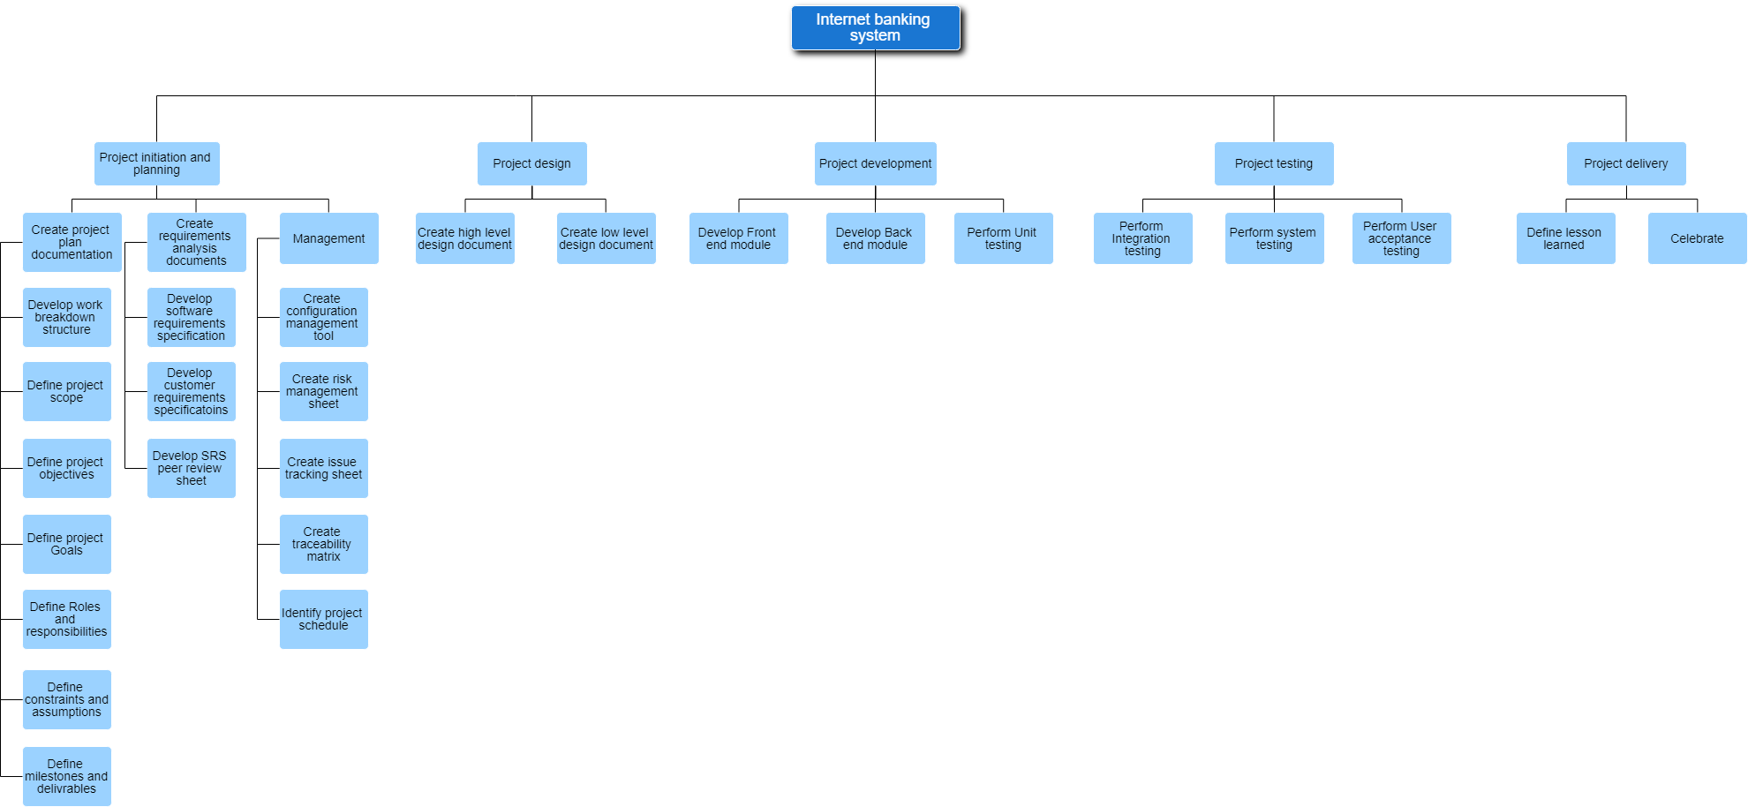

5. Verification and validation

Project verification and validation plan document is available in “Verification and validation document” document file.

6. Approval

* **Sign off sheet**

*I have read the above Project Plan and will abide by its terms and conditions and pledge my full commitment and support for the Project Plan.*

Project Manager:…………………………………………………………… Date:………….

Stakeholder……:…………………………………………………………… Date:………….